

|  |  |  |  |  |  |  |  |  |  |  |  |
| --- | --- | --- | --- | --- | --- | --- | --- | --- | --- | --- | --- |
|  |  |  | **ASSIGNMENT COVER SHEET** | | | | | | |  |  |
|  |  |  |  |  |  |  | **ID** | | |  |  |
|  | **Name** | | Isabella Fickling |  |  |  | **No. 3202254** | | |  |  |
|  | **Lecturer** | | Gary Dix |  |  |  |  |  |  |  |  |
|  | **Course No.** | | DSD 605 |  |  |  |  |  |  |  |  |
|  | **Course Name** | | Software Testing and Security |  |  |  |  |  |  |  |  |
|  | **Assign. Title** | | Assessment 2 |  |  |  |  |  |  |  |  |
|  | **Date Due** | |  | **Date Submitted 08/10/2025** | | | | | |  |  |
|  | **Extension** | |  |  |  |  |  |  |  |  |  |
|  | **Granted to:** | |  | **Date Resubmitted** | | | | | |  |  |
|  | **Date** | |  |  |  |  |  |  |  |  |  |
|  | **Returned to** | |  |  |  |  |  |  |  |  |  |
|  | **Student** | |  | **Date Resubmitted** | | | | | |  |  |
|  | **Date** | |  |  |  |  |  |  |  |  |  |
|  | **Returned to** | |  |  |  |  |  |  |  |  |  |
|  | **Student** |  |  | **Date Resubmitted** |  | | | |  |  |  |
|  |  |  |  |  | | | |  | |  |  |

**Disclaimer of plagiarism and Collusion**

I declare that, to the best of my knowledge, no part of this assignment for the above course has been copied from any other student's work or from any other source except where due acknowledgement is made in the text.

I declare that no part of this assignment has been written for me by another person except where such collaboration has been authorised by the lecturer concerned.

I declare that none of the work has been submitted for any other assignment

**Signature: Isabella Fickling**



**Task 1 –** Password properties

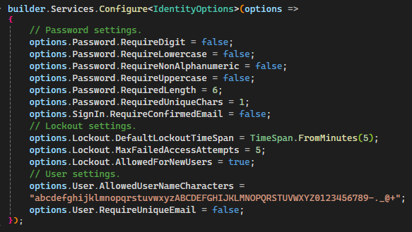

**Task 2 –** Email confirmation

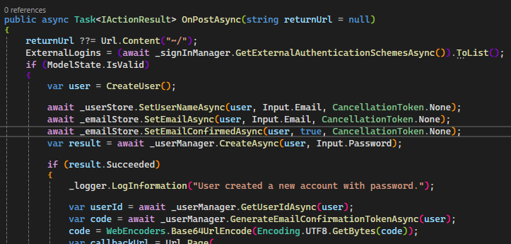

**Task 3 –** Access Denied page

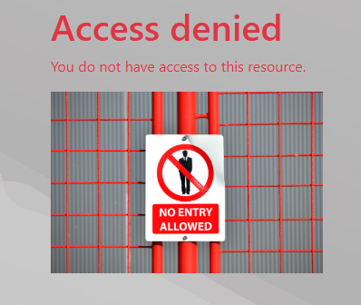

**Task 4 –** User registration

Note: I’ve used the emails provided in the previously used Bike Shop data insert query instead of the assignment details for consistency.

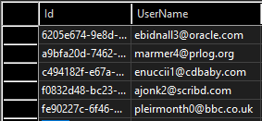

**Task 5 –** Role creation and assignment

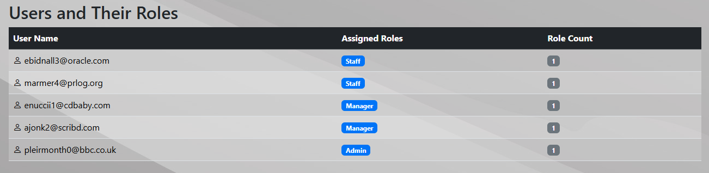

**Task 6 –** Claim creation

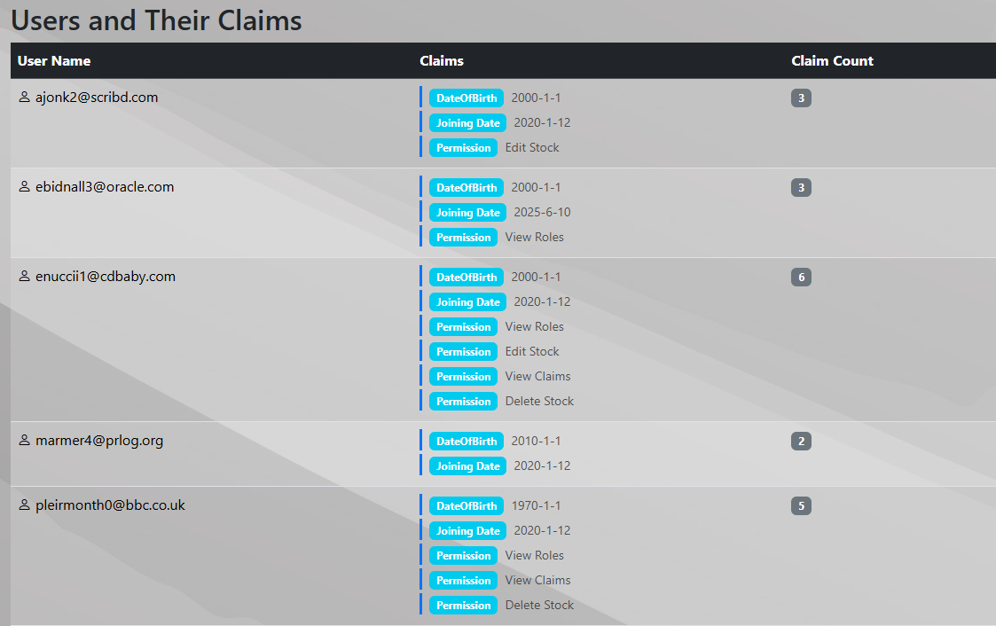

**Task 7 –** Policy creation and application

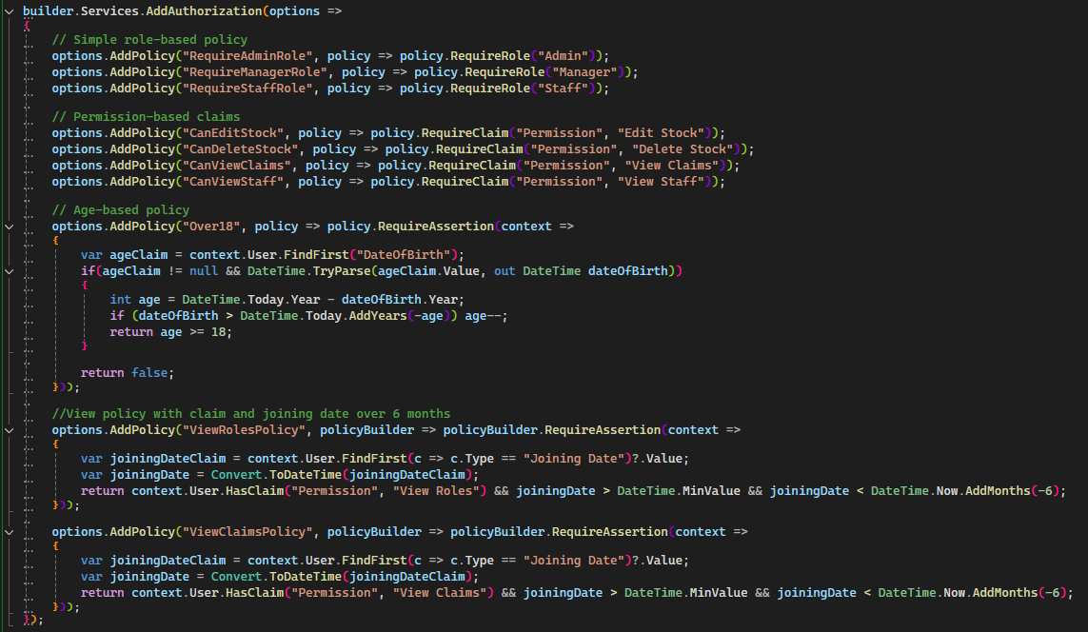

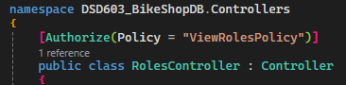

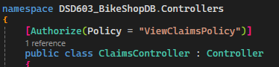

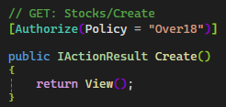

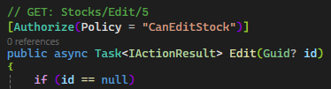

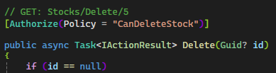

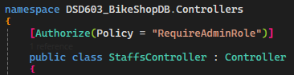

**Task 8 –** Web API React app

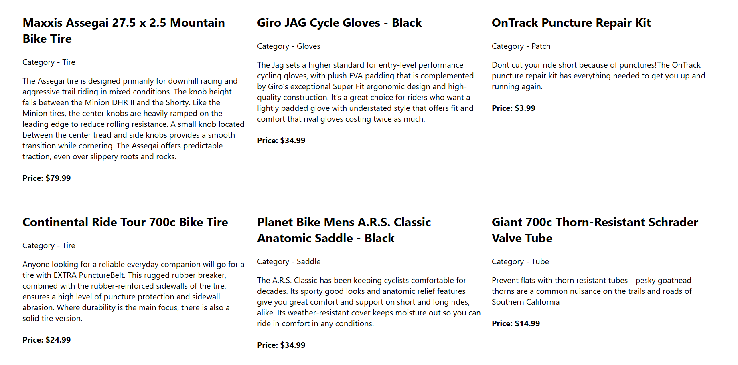

**Task 9 –** Integration test

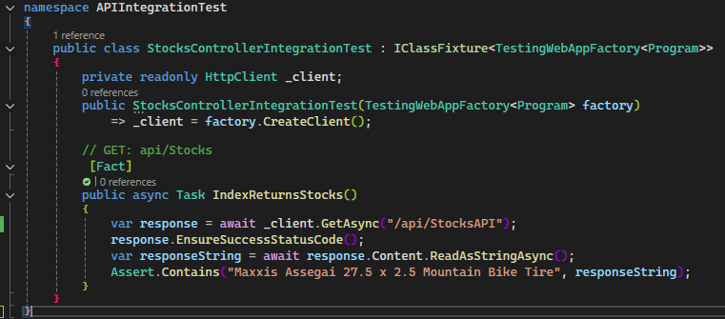

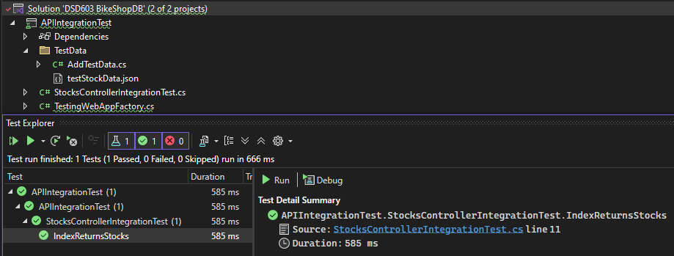

**Task 10 –** Included in Documentation folder of project